

**AMERICAN INTERNATIONAL UNIVERSITY–BANGLADESH (AIUB)**

**FACULTY OF SCIENCE & TECHNOLOGY**

**DEPARTMENT OF PHYSICS**

**PHYSICS 1 LAB**

**Spring 2021-2022**

**Section: B19, Group: 03**

**LAB REPORT ON**

**Study of projectile motion and collision**

**Supervised By**

**MD. SAIFUL ISLAM**

**Submitted By**

|  |  |  |
| --- | --- | --- |
| **Name** | **ID** | **Contribution** |
| **1**. **Sha Sultan Sowhan** | **22-47014-1** | **Discussion and References** |
| **2. Mahmuda Khatun** | **22-47016-1** | **Procedure and Experimental data** |
| **3. Farjana Yesmin Opi** | **22-47018-1** | **Analysis and Calculation, Result** |
| **4. Md. Abu Towsif** | **22-47019-1** | **Theory and Apparatus** |

Date of Submission: **March 22, 2022**

**TABLE OF CONTENTS**

|  |  |
| --- | --- |
| **TOPICS** | ***Page no*.** |
| 1. **Title Page** | 1 |
| 1. **Table of Content** | 2 |
| 1. **Theory** | 3,4 |
| 1. **Apparatus** | 4 |
| 1. **Procedure** | 5 |
| 1. **Experimental Data** | 6 |
| 1. **Analysis and Calculation** | 6 |
| 1. **Result** | 7,8 |
| 1. **Discussion** | 9 |
| 1. **References** | 9 |
|  |  |

1. **Theory**

Projectile Motion:

The motion of projectiles, known to mankind since the times of Archimedes, is an example of two-dimensional motion. This motion occurs in a vertical plane defined by the direction of launch. In the simplest case (when air resistance is neglected and motion occurs close to the surface of earth), the projected body experiences a uniform acceleration along the vertical direction and a uniform velocity along the horizontal direction.

The trajectory of a projectile is parabolic as the figure 1 shows. A study on projectile motion helps in a thorough understanding of the basic concepts in kinematics like accelerated motion, uniform motion, equations of motion and so on.

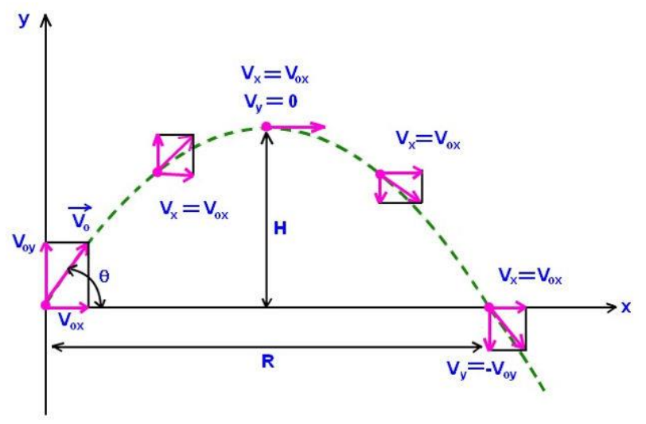

Figure 3.1: The parabolic trajectory of a projectile in the x-y plane. The projectile is thrown with an initial velocity v0 and angle θ with the x axis. R and H represent the range and maximum height of the projectile, respectively

**Collision:**

The elastic collision between a ball and a fixed smooth surface can be presented as the figure

2 shows.

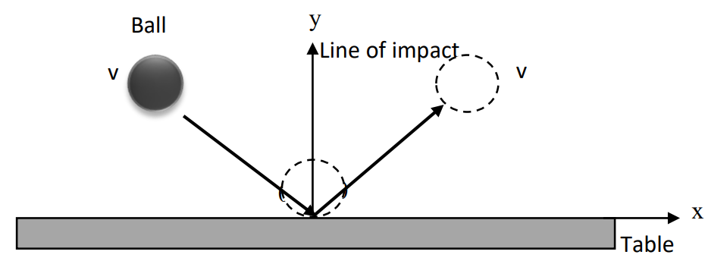

Figure 2: An elastic collision between a smooth ball and a table. The velocities just before and after the collision remain the same.

For an elastic collision, both the momentum and kinetic energy are conserved. The impulse in any dimension (x or y) can be defined as,

Impulse, J = Change in momentum, Δ p = pf – pi ,

where pi and pf are the initial and final momentum, respectively.

1. **Apparatus**

* Marble
* ramp
* clamp
* recording paper
* carbon paper
* meter scale
* weighing scale

1. **Procedure**

1.Firstly, we set up the apparatus as shown in figure 3. We had to make sure that the end of the ramp looks level with the table. Otherwise, we will not get the perfect result of out expectation. Then we laid down a piece of recording paper on the floor and place a sheet of carbon paper on top. So, each bounce of the ball will leave a mark on the recording paper.

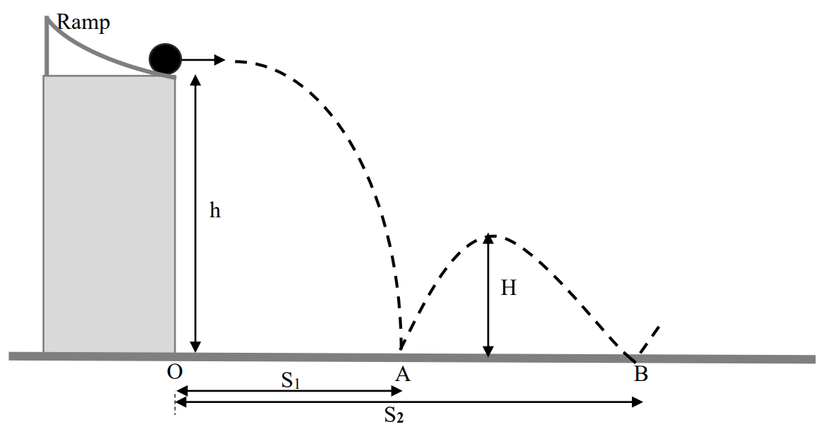2. Once the apparatus is fixed, we must not move the recording paper until the data collection is completed. However, our carbon paper can be lifted at any time to inspect the collision points. Then we located the position O on the floor using the marble ball and measured the distance from O to a reference point on the recording paper. This allows the paper to be moved after the data collection is completed to a more suitable location for the measurements of S1 and S2.

Figure 3: Set-up for the experiment.

3.To collect the data, we released the ball from a point near the top of the ramp, being careful not to impart spin on the ball. This allowed the ball to roll down the ramp and bounce on the floor with minimal spin. We repeated the procedure 10 times always releasing ball from the same point on the ramp.

4. Then we measured the heights h and H with a meter scale as accurately as possible.

5. From the recording paper, we obtained the average values of S1 and S2 in the following way. By eye, we determined the circular region that include most of the marks on the paper (ignore any points that are obviously anomalous). Next, we drew the circle around this region. We took the center of the circles for S1 and S2. So, the radius of the circles as the uncertainties in S1 and S2.

6.At last, we measured the mass of the marble.

1. **Experimental Data**

|  |  |  |  |  |  |  |
| --- | --- | --- | --- | --- | --- | --- |
| Height  h  (cm) | Height  H  (cm) | Average  distance  S1  (cm) | Uncertainty  in  S1  (cm) | Average  Distance  S2  (cm) | Uncertainty  in  S2  (cm) | Mass of  Marble  m  (gm) |
| 52.3 | 14.3 | 40.5 | 3.81 | 81 | 4 | 5.5 |

1. **Analysis and Calculation**

The horizontal velocity Vx of the ball before impact at A equals the horizontal velocity immediately after the rebounds from A. This is a good assumption providing the working table-floor is smooth. Using table-1 according to the fig-3 to calculate the quantities in table-2 and table-3

|  |  |  |  |
| --- | --- | --- | --- |
| Quantity | Straight line (one dimensional) motion | Projectile (two dimensional) motion | |
| Horizontal component | Vertical component |
| Initial velocity | u | V0x = V0cos0 | V0y = V0sin0 |
| Acceleration | a | ax = 0 | Ay = -g |
| Velocity at any  point | V = u + at  V2 = u2 +2as | Vx = V0x | Vy = V0y – gt  Vy 2 = V0y 2 – 2gy |
| Distance | S = vt (constant velocity)  S = ut + at2 | X = V0xt | y = V0yt – ½ gt2 |

Table 2: Equations of motion for one dimensional and two dimensional (projectile) motion

1. **Result**

|  |  |  |  |
| --- | --- | --- | --- |
| SN | Quantities | Corresponding Equations | Values with Units |
| 1 | Time for the ball to leave the ramp and hit the point A | t = $\sqrt{\frac{2h}{g}}$ = $\sqrt{\frac{2×52.3}{980}}$ | 0.3267 sec |
| 2 | Constant Horizontal velocity of the ball | Vx =  = | 123.3267 cm-1 |
| 3 | Vertical velocity just before it strikes the point A | Vy = gt or vy =  = 980 $×$ 0.3267 | $-$ 320.166 cm-1 |
| 4 | Velocity of the ball just before it strikes the point A in vector form | **|v| =**  **=**  tan-1 ( )  = tan-1( | |v| = 343.0973 cm-1  68.9335 $°$ |
| 5 | Range of the second projectile = Distance between point A and B | R = or R = S2 S1  = 8140.5 | 40.5 cm |
| 6 | Time of the ball spends between point A and B | tAB = = | 0.3283 sec |
| **7** | Maximum height for the projectile between point A and B | H = ( )2  = ()2 | 13.203 cm |

Table 3: Some basic quantities related with projectile motion

|  |  |  |  |
| --- | --- | --- | --- |
| SN | Quantities | Corresponding Equations | Values with Units |
| 1 | Magnitude of the velocity before/after impact at point A | **|v| =**  **=** | 343.0973 cm-1 |
| 2 | The angle that the ball makes with the surface just before/after the collision at point A | tan-1 ( )  = tan-1( | 68.9335 $°$ |
| 3 | Kinetic energy of the ball before the collision at A | K.Ei = m |v|2  = (343.0973)2 | 323718.3325 erg |
| 4 | Kinetic energy of the ball after the collision at A | K.Ef = m |v|2  = (343.0973)2 | 323718.3325 erg |
| 5 | Horizontal impulse that the floor gives to the ball | Jx = Pixfx | 0 |
| 6 | Vertical impulse that the floor gives to the ball | Jy = Piyfy | 0 |

Table 3: Some basic quantities related with elastic collision between ball and the fixed surface.

1. **Discussion**

It is normal thing that if we going to do some experiment, we face some difficulties. Here we also face some difficulties. Most of the uncertainty in recording time of flight came from deciding the time for the first data point when the ball is in the air and the last data point before it hit the ground. We estimated that we could be off by one frame. To get a better estimate of this uncertainty, we repeated each measurement many times. The average deviation served as our experimental uncertainty. Our experiment indicates that the time of flight is independent of the ball’s initial horizontal velocity. Air resistance was another obstacle while taking the value. Sometimes we were unable to find out the accurate value. After doing everything properly we were able to get every measure value perfectly and do the experiment accurately

1. **References**

* Fundamental of Physics (10th Edition): Projectile motion (Chapter 4, page 70-

75), Collision and Impulse (Chapter 9, page 266)

* Video Links:
* Projectile motion: https://www.youtube.com/watch?v=rMVBc8cE5GU
  + - https://www.youtube.com/watch?v=pZZt357pkI&list=RDCMUCX1Hh7CvEc3RCUd4NRBWJMw
    - https://www.youtube.com/watch?v=WtfVZdpHZ9o
* Collision: https://www.youtube.com/watch?v=hZm-DcO2JfA